Batch 4- Advanced Business & Interview Query Explanation
Q1 — Revenue vs Order Performance
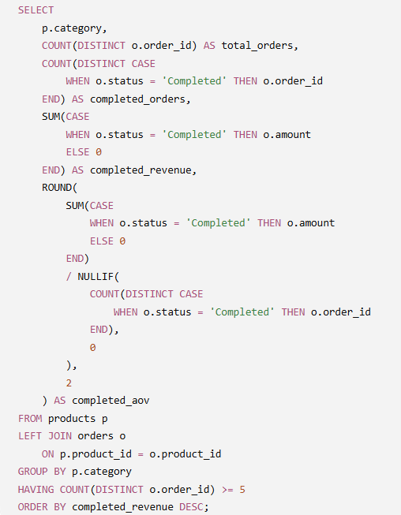
Explain this query:
- What does completed_aov represent?
- Why does the AOV calculation use completed orders rather than total orders?
- Why could a category have lower completed orders but higher completed revenue than another category?
- Why is NULLIF() important in the AOV calculation?
- What does the ORDER BY completed_revenue DESC tell a business manager?
- If Category A has:
  - 100 completed orders
  - ₹50,000 completed revenue
and Category B has:
  - 50 completed orders
  - ₹75,000 completed revenue
which category has the higher AOV, and what business insight does that provide?
- Give a one- or two-sentence executive summary of what this query helps a business understand.
Answers:
- Average Order Value of completed orders.
- Completed orders are the one that have been confirmed so the company has generated revenue, thus actual AOV will always use completed orders.
- The products that the category is offering might be high end, expensive compared to others
- To avoid division by 0
- ORDER BY completed_revenue DESC is immediately highlighting the catogories that are generating the most revenue
- Category B has higher AOV actually 3 times of category A, it tells us number of orders and total revenue have different meanings in business, I personally would like to add marketing budget or add more products in that category
- This is category segmentation, it basically helps to understand which categories are good and which ones bring the business down, where to invest, what can grow our business etc
Q2 — Detecting a Logical Problem
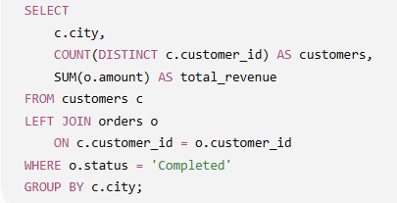
Explain and analyze:
- What does this query intend to calculate?
- Does the LEFT JOIN actually behave like a LEFT JOIN here? Why or why not?
- What happens to customers who have no orders?
- What happens to customers who have only cancelled orders?
- How would you modify the query if the intention was to preserve all cities/customers while calculating completed revenue?
- Explain the logical difference between putting o.status = 'Completed' in the WHERE clause versus inside the JOIN condition.
- Give a concise business interpretation of the corrected query.
Answers:
- City segmentation, total customers per city and the completed revenue
- No, because of the where clause we’re filtering out completed orders rows
- They do not appear in the final output even though we have used a left join
- They do not appear in the final output at all
- Using a case with status condition to calculate the completed revenue and leaving out the where clause
- After the join has been made where is filtering rows, which was not the intention of the above query
- For each city, show the total customer base and completed-order revenue, while preserving cities whose customers have no completed orders
Q3 — Query Logic & Business Interpretation
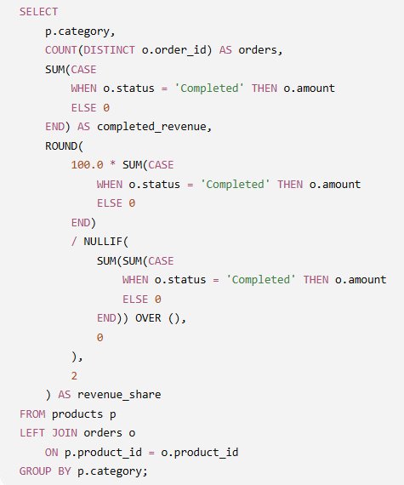
Explain:
- What does completed_revenue represent?
- What does revenue_share represent?
- Why is SUM(SUM(...)) OVER () being used?
- Why is NULLIF() still necessary?
- If Category A has revenue_share = 40%, what does that mean?
- Why is revenue share potentially more useful than looking only at raw revenue?
- What business decision could this analysis support?
Answers:
- Sum of amount for completed orders
- Completed revenue share of a category in % from the total completed revenue
- To calculate the overall sum of completed revenue across categories in the same query
- To avoid division by 0
- 40% of the total completed revenue is coming from category A and remaining from other categories
- % gives a better idea in terms of contribution
- Which categories are dominating the revenue and which are performing poorly, according we can take business actions

Q4 business logic trap.

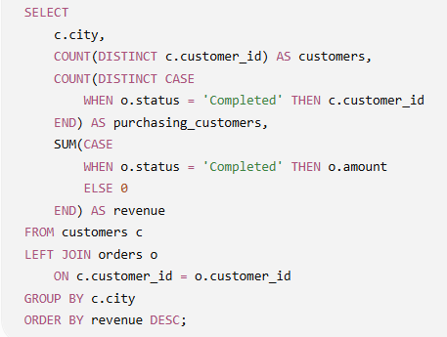

A manager says:

"The city with the highest revenue must be our best-performing city."

Your task:
- Do you agree with the manager? Why or why not?
- What does customers tell us?
- What does purchasing_customers tell us?
- What important metric can we derive from these two columns?
- Why might a city with lower revenue actually be more efficient than the city with the highest revenue?
- Give two additional metrics you would want before deciding which city is truly performing best.
- Give your response to the manager in 2–3 sentences, as if you were the analyst presenting this result.

Answers:
- Before coming to a conclusion we have to consider other metrics as well, like total customer, conversion rate, cancellation rate etc.
- Unique customers from a city
- count of customers who have placed at least 1 completed order
- purchase rate and contribution to total revenue
- conversion rate might be higher, no. of customer is attracts, repeating customers etc.
- conversion rate, cancellation rate, overall contribution
- this query is insufficient to classify a city as the best performing city, we have to calculate many more metrics and then come to a better understanding of each city’s performance.

Batch 4 — Q5

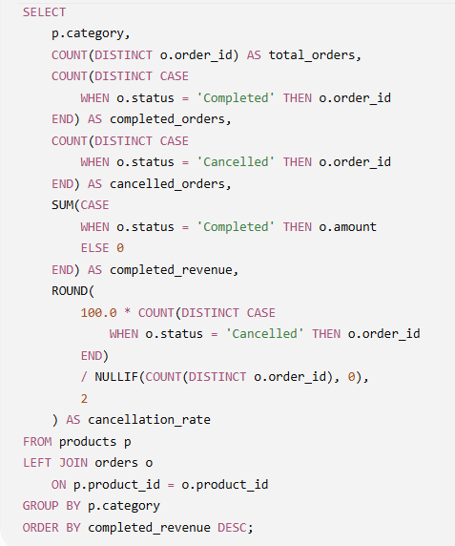

A manager says:

“Category A generates the highest completed revenue, so we should shift most of our marketing budget toward Category A.”

Answer these as an analyst:
- Do you agree with the manager's conclusion? Why or why not?
- What does total_orders tell us?
- What does completed_orders tell us?
- What does cancelled_orders tell us?
- Explain exactly how cancellation_rate is calculated.
- Why could a category with the highest revenue still be a poor choice for additional marketing investment?
- Give three additional metrics you would check before reallocating the marketing budget.

Answers:
- No, we have to consider a lot of other metrics like cancellation rate, conversion rate, overall contributing in revenue
- Total order that a category is getting
- Completed orders in a category
- Cancelled orders in a category
- Cancelled orders divided by total order multiplied by 100 to calculate the %
- Without considering other metric that we have mentioned above as well as guardrail metrics, coming to a conclusion on the basis to total revenue would not be wise
- Category share in revenue, completion rate and AOV

Q6 — Final Interview Question

Consider this business situation:

A company notices that completed revenue increased by 25% this month. The marketing manager says:
“Great! Our marketing strategy is clearly working.”

As the analyst, explain why you would not immediately accept this conclusion.

Cover these points:
- Give at least four possible reasons why revenue could increase without marketing actually becoming more effective.
- Which SQL/business metrics would you investigate first?
- How would you distinguish between more customers, more purchases from existing customers, and higher order value?
- Why should cancellation rate be checked?
- What role could product mix play?
- Give a concise 2–3 sentence response to the marketing manager.

Answers:
- a) seasonality b) discounts/offers c) better high intended customer mix d) novelty effect
- new customer and returning customer comparison
- more customers mean we have acquired new customers, more purchases from existing customers sounds good but there can above mentioned reasons, higher AOV could mean more high end products have been introduced, or due to offers or schemes customers are buying more than they intended
- it’s really important to figure out how many of the orders are actually being cancelled, is there a friction somewhere between the customer and the business, the customer mix is biased towards casual browsers, is there faith issues on the customer end, are customers actually finding what they are looking for.
- Some products might be in high demand, affordable or utility household other might be expensive, low demand and for pleasure, these can definitely effect the purchase and other metric
- I’d say, keeping seasonality, customer demand, guardrail metrics affordability of products and customer mix and geography that we have we should stock up or invest in those products/categories. The 25% increase in completed revenue is encouraging, but it doesn't by itself prove that marketing became more effective. I'd first decompose the growth across new vs returning customers, orders, AOV, product mix, cancellation rate, and channel performance to determine whether the increase was actually driven by marketing

